Arrhythmia Review 7/ 2005

Hi all – here’s another one – this one took a while, but it was a lot of fun to hunt around for strips and images. As usual, please remember that this file is not meant to be a final medical reference of any kind, but is meant to represent knowledge passed on by a preceptor to a new orientee. Please let me know when you find mistakes, which I’m sure you will!

- What is an arrythmia?

The nodes: SA and AV.

The normal complex:

1-1: What is a P-wave? What is the P-R interval?
1-2: What if there’s no P-wave?
1-3: What is the QRS complex?
1-4: What if there’s no QRS complex?
1-5: What is the T-wave? What is the QT interval?
1-6: What if there’s no T-wave?
1-7: What is the isoelectric line?

- Why do people have arrhythmias?
- What is the difference between a bad arrhythmia and a not-so-bad arrhythmia?
- What is “ectopy”?
- What does “supraventricular” mean?
- What are the supraventricular arrhythmias that I’m likely to see in the MICU, which ones do I need to worry about, and how are they treated?

6-1: Sinus arrhythmia
6-2: Sinus bradycardia
6-3: Sinus tachycardia
6-4: Paroxysmal Atrial Tachycardia (PAT)
6-5: PAC’s
6-6: Atrial bigeminy
6-7: A-flutter
6-8: A-fib
6-9: Wandering Atrial Pacemaker & Multifocal Atrial Tachycardia (MAT)

Continuing southwards…

6-10: Nodal beats
6-11: Junctional “escape” beats
6-12: Escape capture bigeminy
6-13: Junctional rhythms
6-14: Accelerated junctional rhythms
6-15: What if the atria and the ventricles aren’t talking to each other? How can I tell?

6-15-1: What is A-V dissociation?
6-15-2: What does “marching out” mean?

Even Further On South… how this FAQ is organized.

- What ventricular arrhythmias am I likely to see in the MICU, when should I worry about them, and how are they treated?

7-1: PVCs
7-1-1: What are couplets? Triplets?

7-2: Ventricular bigeminy, trigeminy, quadrigeminy?
7-3: What is a “run”? What is a “salvo”? What is “Non-sustained ventricular tachycardia”?
7-4: VT
7-5: VF
7-6: What is the difference between “narrow complex” and “wide complex” tachycardia?
7-7: What do I do if I see VT on the monitor?
7-8: What if the patient is still awake?
7-9: What if the patient rolls up her eyes and becomes unresponsive?
- 7-10: What is a precordial thump? Does it work?
- 7-11: What if I see VF on the monitor?
- 7-12: Torsades de Pointes
7-13: AIVR
7-14: Asystole

- Things we left out the first time:

8-1: SVT – Supraventricular Tachycardia
8-2: WPW – Wolff-Parkinson-White

9- Quiz Questions

- What is an arrhythmia?

By the time they get to the MICU, most people have a good basic idea of what arrhythmias are all about, but enough new people are coming in that we thought it might be helpful to put together a quick review.

The idea that helped me the most in actually understanding what arrhythmias do to people was correlating, or maybe I should say learning to visualize in my head, what the heart was actually doing during one arrhythmia or the other. Each part of the normal cardiac cycle has a specific mechanical event associated with it, and if you can get a mental image in your head of what is, or isn’t happening, then the effects of the arrhythmias become much clearer.

The Nodes:

Take a look at the diagram that follows.

Remember these? These are the “intrinsic pacemakers”. Not too hard – there’s only two of them. First is the sino-atrial node – which lives in the right atrium, in something called the coronary sinus, which I have no idea what exactly is, exactly. Jayne knows – she works in the EP lab… anyhow, there it is in the picture, in yellow up at the top. This is the one that generates P-waves. P-waves travel from the SA to the AV, or atrioventricular node, which lives at the place where the atria and the ventricles join. As the signal travels through the RA, both atria contract.

This is the key thing: as the signal goes through its part of the heart, that same part of the heart responds mechanically, with movement.

Well – it’s supposed to! (grin! – what if it doesn’t? What’s that called? What would you do?)

That movement, of one set of chambers or the other – atria or ventricles - is what you want to try to visualize mentally as you think your way through arrythmias. So: P-wave – atrial contraction.

Next comes the AV node, which is also called the “junction”, and sometimes confusingly called “the node” – even though its sibling up above is also called a node. (I have no idea where this second name came from – anybody know?) The signal that came from the SA node gets to the junction, and is passed along to travel through the ventricles, producing the QRS complex on the EKG. In response to this part of the signal, the ventricles contract. So this time: QRS – ventricular contraction.

Let’s take a second to look at how lead II works:

Negative electrode goes here

(here) (Ground electrode goes here…)
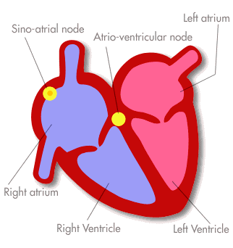
(here)
Positive electrode here
www.arrhythmia.org/ general/whatis/

The point here is that the normal pathway that the signal takes is going from the negative electrode, towards the positive one. See that? Going towards the positive electrode, the signal makes an upward blip on the cardiac monitor.

This is actually really important, and I’ll probably make this point too many times, but the direction in which the signal is moving tells you where the beat is coming from. If it makes an upward blip on a lead II, then it has to be moving in the normal direction, towards the positive electrode. So it must be coming from somewhere in the normal pathway: either the SA or the AV node. If the signal goes downwards – meaning, the signal is going the other way, backwards towards the negative electrode – where’s it coming from?

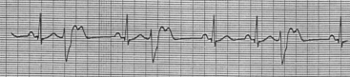
Like these guys. They go downwards, mostly, right?
So – they’re going the wrong way. Hm. So that means they must be coming from where? Well… they’re PVC’s, right?
Premature… aha! - ventricular contractions! They’re going backwards because they’re coming from the other end of the heart, down in the ventricles, and heading backwards towards the negative electrode in lead II… so the signal goes downwards… bing! Lightbulb go on? Which way are the normal ones headed?

See why Lead II is used as the standard monitoring lead? It reflects the normal conduction path.

A word about depolarization - my son wanted to explain this, because he’s figured out what it means. “Depolarization is when you take one of those white bears, and take it away from the arctic – it gets depolarized!” - just so everybody’s clear on that one…

The Normal Complex:

Now let’s take a quick look at the normal cardiac cycle on the EKG:

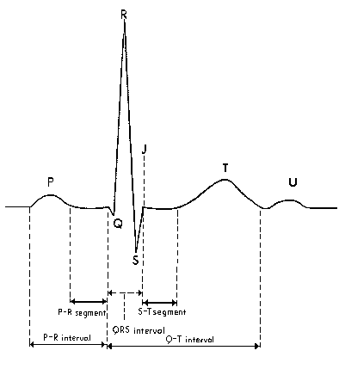
www.bilgi.umedia.org.tr/ yayin/tejm/ekg.htm

This is a pretty good diagram – looks like lead II from a 12-lead EKG. Let’s say it again: Lead II is used as the basic reference lead for looking at cardiac rhythms, because it reflects the normal path of the signal moving through the heart. In lead II, the positive electrode is near the apex of the heart - the bottom of the cone formed by the ventricles, pointing southeast; (that’s “down and towards the right” for you non-map people – ow! Violent daughter. Who exactly do you think paid for drivers’ ed, anyhow?) The negative electrode is up on the right chest near the clavicle, northwest. Now imagine a line drawn connecting the two electrodes. Got that? The normal signal follows that path, moving through the chambers, always towards that positive electrode, making an upward blip on the ekg trace as it does. See those upward blips?

Now – everybody knows where the electrodes go, right?
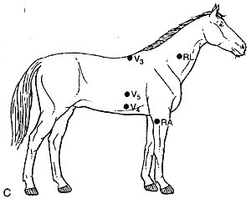
(What do you mean, “Nice picture of your first girlfriend!”?)

1-1: What is a p-wave? What is the PR interval?

So. In lead II, as the signal goes through the small muscle mass of the atria, it generates a small upward wave – you guessed it, the P-wave. Atrial depolarization ends, sort of obviously, at the AV node – at the beginning of the QRS. Actually we ignore the Q-part of the complex in measuring the PR interval. A normal PR interval is supposed to be equal to, or less than .20 seconds (5 little boxes, or one big box on the EKG paper.)

1-2: What if there’s no P-wave?

No p-wave means that the SA node hasn’t generated a signal. No signal, no atrial motion. Can you live without atrial motion? – probably, although you lose your atrial kick – which they say accounts for something like 25% of your total cardiac output.

1-3: What is the QRS complex?

As the contraction signal gets passed along through the large muscle mass of the ventricles, it generates a large waveform. The QRS is not supposed to be longer than .12 seconds – three little boxes. Longer means the signal is taking longer than it should to get through – maybe there’s a bundle branch block?

1-4: What if there’s no QRS complex?

No QRS complex means that no signal has gone through the ventricles. No signal, no ventricular motion. Can you live without ventricular motion?

1-5: What is the T-wave? What is the QT interval?

Now that both sets of chambers have contracted, the electrical system resets itself – producing the T-wave. The significant thing we worry about as regards an otherwise normal T-wave is the length of the waveform: from the beginning of the QRS to the end of the T-wave, called the QT interval. A “corrected” QT interval that lasts too long can mean that bad things may be developing – usually one kind of drug toxicity or another – which may show up as nasty tachyarrhythmias like VT. Haldol is infamous for this.
1-6: What if there’s no T-wave?

Well – if there’s no QRS, there won’t be a T-wave. Otherwise, the ventricles are definitely going to have to reset themselves – producing a T-wave of one kind or another. It’s very important to remember that T-waves, or more correctly the ST segment of the complex, can change if the patient goes through an MI, or is having an ischemic, or anginal episode. If the T-waves on your patient look different at the end of your shift – get suspicious. There’s lots more on ST segments and what they’re trying to tell you in the FAQ on “Reading 12-lead EKGs”.

1-7: What is the isoelectric line?

Let’s look at a normal sinus rhythm strip.

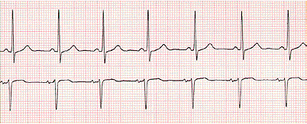

Do you see the area where the line is flat between the beats? After the T-waves, and before the next p-waves? That’s the “isoelectric line”. When ST segments go up, as in an MI, or down, as in ischemia, what you’re hoping is that they will come back to their original positions with treatment, and that position is: where they started out, on the isoelectric line.

- Why do people have arrhythmias?

Lots of reasons, but if you think about things that are going to make a heart unhappy, then those are the things that will produce arrhythmias acutely: cardiac ischemia, hypoxia, MI, changes in electrolytes…obviously in a situation like this you are going to be treating the underlying problem – either with anti-ischemic treatments in situations like anginal CHF (remember “LMNOP”- Lasix, Morphine, Nitrates, Oxygen and Position); or clot-busting an acute MI – and hopefully this will minimize or even reverse the conditions that are producing the arrhythmias in the first place.

Chronic changes that produce arrhythmias have to do with processes that make cardiac chambers do things over long periods of time that they don’t want to do, usually producing an abnormal change in their size. Anything that makes a chamber “stretch” chronically will produce chronic arrhythmias – the classic example is cor pulmonale (“lung-heart” – meaning, heart problems caused by the lungs.) The lungs, remember, are supposed to be nice and soft, and the relatively thin-walled right ventricle doesn’t have any trouble sending blood through them. Any process that makes the lungs stiffen up - whether acute or chronic - will increase the pressure needed to send blood through them. Now the RV has to work harder, and since it’s not built too powerfully to start with, if it’s made to work harder over time, it’s going to grow – like your biceps do during weight training (mine never did…).

This chamber growth is actually not a happy thing, because the heart wants to stay small – it works better that way, small and tight – and the bigger it gets, the more stretched and boggy it gets, and this stretching and bogginess characteristically produces arrythmias. I was taught that a stretched-out RV and RA produces atrial fibrillation – the classic arrhythmia of smokers and COPDers. And liver patients. Make sense?

We had another neat example of chronic chamber stretch recently: patient came in with a primary liver tumor that had been treated for a while. He was in a-flutter, probably because the impaired perfusion through the liver had kept his right sided pressures high for a long time. (His CVP was 20, and he was not wet – wasn’t making much urine.) Right-sided stretch.

Likewise, anything that makes the left side of the heart grow and stretch will produce arrhythmias – usually the more unpleasant ventricular ones. These will be your CHF patients with low EF – they will often have a certain amount of ventricular ectopy at baseline, and you’ll hear people say “Is Mr. Yakowitz allowed to have triplets, or should we wake up the team to look at him?”, and someone will answer, “Oh yeah, he has them all the time whenever his K gets below 4, and we’re not supposed to call the team unless he starts having long runs.”

- What is the difference between a bad arrhythmia and a not-so-bad arrhythmia?

The key concept: is the patient able to make a blood pressure? I mean, clearly there are lots of other things to consider – for example, a patient may go into VT and maintain a blood pressure nicely, talking to you, maybe complaining of chest pain – would you shock that patient? You would need to know that in VT, a patient may sometimes maintain a pressure for a while, and then lose it abruptly – does this happen with other arrhythmias? It takes time, study and experience to learn your way around these situations – don’t feel bad if you find that it takes you quite a while. It takes years to get comfortable in the ICU. I’m still waiting…

Let’s try the visualization thing to see if it helps to analyze the threat that is produced by one arrhythmia or the other. Here’s an example – you’ve probably seen people with this.

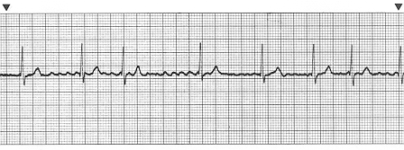

Right – here we are in A-fib. Are there P-waves? Hmm – maybe? What are those fluttery looking waves along the isoelectric line? Not really p’s. So - no P-waves means: no kind of normal atrial contraction. Are there QRS’s? Definitely. So there are ventricular contractions – and how many in a minute? This looks like a six-second strip - count the QRS’s and multiply by 10 to get the ventricular contractions in one minute. Everybody get 70? (Don’t count that last QRS at the end – it’s beyond the 6-second measurement).

Should this patient be able to maintain a nice blood pressure with a rate of 70? Probably – the ventricles need time to fill up, and at this rate they’re probably filling very nicely. A lot depends on the strength of the ventricle – the “ejection fraction”. There’s all sorts of good stuff about EF, and filling pressures and the like in the PA-line FAQ.

Now the mental part. (My wife laughs at this point.) In my mind, when I see a-fib, I think of the atria, uh… fibrillating. Remember the “bag of worms”, which is how they describe what a fibrillating ventricle looks like? Same thing, but up on top. The ventricles, I can see, should be pumping properly, because there is a normally upright QRS – this means that the path of conduction is travelling in the right direction through the ventricular muscle mass, just the way it normally should – so they’re at least conducting okay.

The important points in this situation:

- I recognize this as A-fib, which is a fairly “stable” arrhythmia – it may be cheating in a FAQ for new RNs to say that the old guy already recognizes the rhythm, but we learn by example, right?

- The ventricular rate is not too fast. This is a very important concept in grasping the significance of arrhythmias: speed matters - usually we’re talking about ventricular speed here. Ventricles beating at a rate of 200 bpm have no time to physically fill up with blood – therefore they don’t have much blood in them to pump out – therefore cardiac output and blood pressure fall, and other bad things like death may ensue. Too slow a rate may have the same result – sure, the ventricles have all the time they need to fill, but at such a slow rate, the cardiac output is still too low to maintain a blood pressure. What’s the ventricular rate in the strip above – 70, we said? Sounds good to me. If the ventricular rate is kept around this range, the patient will probably do fine.

- A helpful basic concept: the ventricles do most of the pumping in generating a blood pressure. The rule is, no matter what else is happening, if the ventricular rate is somewhere near the normal range of sinus rhythm – say 60 to 100 bpm, then the resulting blood pressure will probably be all right. Probably. (grin!)

- What is “ectopy”?

“Ectopic” means: “something occurring where it isn’t supposed to”. Pregnancy anywhere in the body but the uterus is “ectopic pregnancy”. Seizures result from ectopic electrical activity in the brain. If the signal that starts a heartbeat originates from someplace other than it’s supposed to, it’s also called ectopic.

Two points to make here: first, you’ll remember learning years ago that cardiac tissue has the property of “automaticity” – which means it is able, all of it in one way or another, of acting as a pacemaker, not connected in any way to the normal, built-in pacemaker/conduction system.

Second, the heart responds to the fastest signal it receives. This means, for example, that if the AV node should wake up and start feeling frisky and quick, it could capture and pace the heart if it were generating a rate faster than the SA node. (CCU nurses in the audience – what arrhythmia would this be?)

The result is that electrical pacemakers can pop up just about anywhere – in the atria or in the ventricles, and if they produce a beat sooner than the current pacemaker (I’m talking about built-in, natural pacemakers here) does, that ectopic beat will capture the heart. For example, a single PAC. Or a single PVC. The idea is that these signals are premature, arriving sooner, at a faster rate than whatever else is normally pacing the heart. As a result, they capture.

Or, if it’s a sequence of rapid signals, it will capture the heart for as long as that sequence lasts – any examples from the audience? VT for sure. SVT also for sure – rapid Afib as well. (Pardon me – supposed to say: “A-fib with RVR” – rapid ventricular response…) The normal, slower rhythm will not recapture the heart until the faster rhythm is controlled – and if the rapid rhythm doesn’t allow the ventricles enough time to fill, there you have your lethal arrythmia situation. More on these later.

- What is “supraventricular”?

You’d think that this meant “atrial” in reference to arrythmias, but I believe we’re supposed to add AV-nodal (sometimes called “junctional”, or just “nodal”) rhythms to this group.

- What are the supraventricular arrhythmias that I’m likely to see in the MICU, which ones do I need to worry about, and how are they treated?

Let’s begin by looking at normal sinus rhythm – the normal supraventricular rhythm:

Look familiar? Normal intervals, rate in the 70’s – nice! Everybody see the p-waves – the little ones in front of the big ones? Then the QRS’s, which are the big ones. Then the t-waves, coming after the QRS’s…

Here are some of the common supraventricular arrythmias – some aren’t really so common, but you should have a basic grip on them anyhow.

6-1: Sinus arrhythmia

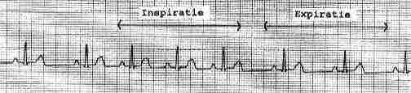

This is not one to worry about, as far as I know. Sinus arrhythmia is when the normal sinus rate speeds up and slows down slightly, varying with respiration. In 26-odd years I’ve never seen any physician show the slightest concern about this one. (French website…)

6-2: Sinus Bradycardia

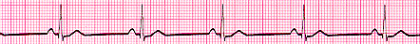

Here’s a nice sinus bradycardia, rate in the 50’s. Everyone remember what the intrinsic rate is for the SA node: 60 to 100bpm, right? Is this rhythm coming from the SA node? Sure – see the p-waves? But it’s slow, isn’t it? – “bradycardia”, of sinus origin. Sinus bradycardia is sometimes a good thing – it means your patient has finally fallen asleep, or that her metoprolol is finally starting to work. A really slow bradycardia is not such a good thing – clearly, you don’t make much of a blood pressure with a rate of 20.

Scenarios causing sinus bradycardia:

- Inferior MIs – “IMI”s – are classically famous for producing brady episodes, where the patient’s rate drops to the twenties, and you run into the room and give a milligram of atropine, and start looking around for the external pacing pads. If I’m getting a patient with an acute IMI, I put a vial of atropine in the room just for good voodoo. Mojo. Whatever.

- Sedation: being sedate will drop most people’s heart rates.

- Ischemia: definitely. If you think about it, you’ll remember that there are three main coronary arteries – these perfuse the SA and AV nodes, and if the nodes become unhappy, then arrhythmias certainly result. As with an IMI, in the case of ischemia in inferior territory, the RCA is usually the problem… there’s lots more on the coronary arteries, where they go, and how they show up electrocardiographically in “Reading 12-lead EKGs”.

6-3: Sinus Tachycardia

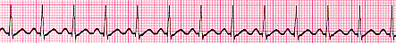

Sinus tachycardia – pretty easy. P-waves? Yes. So the rhythm is coming from the sinus node. What’s the rate – somewhere near 130? So, faster than the normal range of 60-100. Tachycardia. Let’s do the mental thing just quickly: P-waves mean that the atria are contracting, QRS’s mean that the ventricles are too, and in the right order, atria first, ventricles second. Which is of course better than if they’re doing it backwards – or even simultaneously, which does happen sometimes.

Reasons for sinus tachycardia:

- Agitation, pain or distress – pretty easy.

- Fever – also pretty easy.

- Dehydration – anything that decreases the circulating volume for any reason will produce a rise in heart rate, as the body tries to keep blood pressure up. Dehydration would mean a relative loss of water in the circulation, but certainly blood loss will do the same thing. There’s lots more on how blood pressures work in “Pressors and Vasoactives”, and “PA – Lines”.

- There can certainly be combinations – it wouldn’t be unusual at all to see all three of these conditions at once in a septic patient. Remember – sinus tachycardia is usually something the body is doing on purpose, for a reason, such as trying to maintain a blood pressure. Don’t be too anxious to start giving drugs like beta-blockers in tachycardic situations until you have some idea of why the patient is doing what they’re doing. (The exception would be during an acute MI. Hearts get tachycardic during MIs, usually because their owners are in pain, or terrified, or both. Bad.)

6-4: Paroxysmal Atrial Tachycardia (PAT)

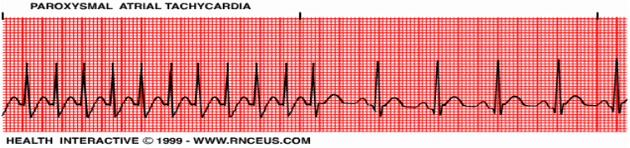

PAT is a very rapid supraventricular rhythm that comes from the atria – usually it runs at a very rapid rate, about 250-300bpm. You sometimes see young people have short bursts of this rhythm, which in my experience doesn’t last more than a couple of seconds. How much caffeine did they drink today? This strip shows the PAT breaking spontaneously to NSR. It may set your alarms off – unless it persists, most physicians don’t get too involved with this. Document it. If it persists – as what you would then probably call SVT - things could get ugly, in the sense that the blood pressure might suffer – what drugs would you think about having on hand for this? Might need a machine, too.

6-5: PAC’s: (Premature Atrial Contractions)

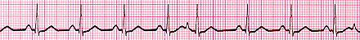

Here are some nice premature atrial contractions. That is, we assume that the heart is contracting in response to these signals. Anyhow, if you look at the early beat – 5th complex, right? – you’ll see that it has a different P-wave shape (the impressive word for shape is “morphology”), meaning that it comes from someplace other than the normal sinus node. (My son loves to find little words that mean the same as big ones. “Yo Ralphie! Your face has a weird morphology!”) Ectopic. The other thing you’ll notice is that it comes too soon – it’s premature. Coming sooner than the normal SA node impulse, the PAC captures the heart, just for that one beat – then that ectopic source (an ectopic pacemaker is often called a “focus”) shuts off again, and the regular sinus rhythm comes back. To speak impressively, remember to say that the different p-wave “has a different morphology, arising from an ectopic focus”. Wooo….

PACs don’t get physicians worried, as a rule. The thing to worry about is: if they start getting too frequent, it may mean that a-fib is coming.

6-6: Atrial bigeminy – this means that every other beat is a PAC. Again – afib may be coming.

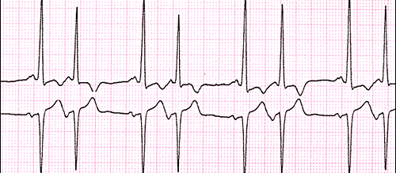

6-7: Atrial Flutter

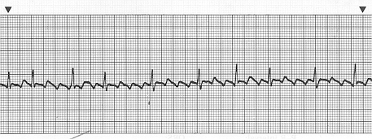

Right – here we are in atrial flutter. Pretty! Remember: a normal, upward QRS means that the conduction from the AV node on down is in a normal direction – assuming this is a lead II. That means that conduction through the ventricles is happening the way it’s supposed to.

So what are the atria doing here? Who said “fluttering”? (I seem to be visualizing an audience here.) You in the back, very good. How did you guess? You get to buy lunch. Right – the atria, if you looked at them, would be contracting at about what rate – you guys know how to count boxes to determine rates, right? We’ll get to that later – in a-flutter, the atria contract at a rate around 300 bpm. Are all the signals from the atria being conducted to the ventricles? No? Good thing! Would the ventricles have time to fill if every atrial signal made the ventricles contract – at a rate of 300 bpm? Nope! What’s the ventricular rate? Six-second strip, count the QRS complexes, multiply by 10 – about 100 – close enough to a normal sinus rate to tell us that the patient is probably going to generate a decent pressure with this rhythm.

What’s the ratio of atrial to ventricular contractions here? 300 atrial bpm, 100 ventricular bpm – I would call this “3-to-one a-flutter”, and I would document the rhythm carefully strip-wise, but seeing this rhythm wouldn’t make me very nervous. A-flutter is usually transient – people don’t stay in it too long, because they’re usually on the way towards developing a-fib.

Another point worth mentioning – the ventricles are responding to roughly one out of three signals here, right? This is called the “ventricular response rate”. Duh. But obviously, it matters a lot, because if the response rate gets too high, then the chambers don’t fill, and the pressure drops, and etc. What if the ratio were 2-to-1? What would the ventricular response rate be? Around 150 – not too too fast, but pretty darn fast, faster than I’d like to see my patient go, especially some older MICU patient who gets ischemic very easily – what in this case would be called “rate-related ischemia”. I would definitely wake up the team for an episode of 2:1 flutter, for that very reason – in the old days physicians would compress one of the carotids to try to provoke the “carotid body response” – namely, bradycardia, specifically by slowing AV node conduction – partly a diagnostic, and partly a therapeutic maneuver. (We used to call this “doing the neck thing”, as in “Are they gonna do the neck thing?”) You would look for the ratio to change – fewer QRS’s.

I got lucky hunting around – here’s a really neat strip of someone “doing the neck thing”, otherwise known as “carotid sinus massage”.

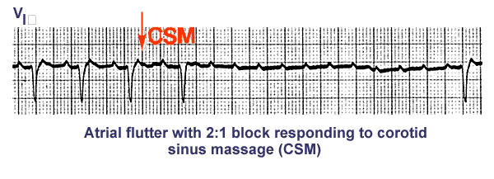
Nowadays they don’t do the neck thing much any more, since people with carotid disease don’t usually enjoy it too well – threatens the brain, and all – although some physicians will do it if they don’t hear any carotid bruits on exam. Instead you may see maneuvers with verapamil, sometimes metoprolol, sometimes adenosine – I’ve seen all of them work, but my experience leans toward verapamil in this situation. I hate adenosine – ten seconds of total terror…

6-8: Atrial fibrillation –

Okay, here’s the nice picture of a-fib that we looked at earlier. A-fib is a pretty similar scenario to a-flutter – the atria are doing the worm dance, and only the occasional signal gets conducted through the AV node to the ventricles, which is a good thing! Remember, you want the ventricular rate to be something like what the normal sinus rate would be – 60’s to about 100. Let’s do the mental thing – what are the atria doing? Is there a nice stable p-wave? No. Can you visualize the motion of the atria? Bzzzzz – fibrillating, and not contracting in any organized way. Signals are not coming from organized sources, or “foci”, but from all over the atrial tissue, simultaneously. Some signals are getting through the AV node and being delivered to the ventricles – again, they speak of “ventricular response rate” – you’ll hear people describe an episode of “rapid afib with RVR” – rapid ventricular response – which may require a quick cardioversion back into sinus rhythm to restore a failing pressure. Or the patient might need IV blocking agents of one kind or another – betas, calciums, digoxin maybe (takes a day to work), to bring the RVR down to a rate that produces a better pressure.

Once brought under control rate-wise, afib in and of itself is a stable arrhythmia, but it does have a couple of significant bad things that go with it:

First, fibrillating atria don’t empty themselves very well. The result is that clots can form in them, and if the a-fib suddenly converts back to sinus rhythm, those clots will get shot out into the circulation – arterial or venous, or both – off to the lungs if on the right side, producing a PE, or if on the left, then off to all sorts of interesting places down the arterial tree, such as brain, or foot, or mesenteric artery (producing bowel infarct), or elsewhere. “Paroxysmal a-fib” as a result is seen, rightly, as very dangerous. What could you do to prevent this from happening – not the a-fib, I mean, but the clots? Audience? Right – anticoagulation. Acutely, with heparin, long-term with coumadin. What if the patient was HIT positive?

Continuing southwards…

Working our way south from the SA node, the next source of arrythmias is the AV node, otherwise called the “junction” – or just “the node”, as in producing “nodal rhythms”.

6-9: Wandering Atrial Pacemaker & Multifocal Atrial Tachycardia
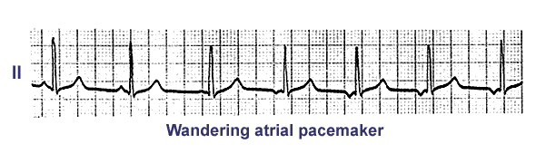
Here’s a rhythm you see once in a while – see how the p-waves have a number of different morphologies? (79 cents for the word, please.) The idea here is that the atrial focus shifts from the SA node to the atrial tissue, in various places, each of which generates it’s own signal, which goes on to capture. If the rate is less than 100, they call it WAP – if it’s over 100, the name changes to Multifocal Atrial Tachycardia.

6-10: Premature nodal beats

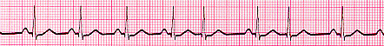

Everybody see something strange in beats 5 and 7? Are they early? Sure. Are they PACs? There’s no p-wave, is there? But look – the direction of the QRS is normal – this means the signal is moving in the normal direction through the ventricles.

These are premature nodal, or junctional beats. No p-wave means they’re not coming from the atria. What’s happening here is that sometimes the junction, for reasons of its own – will accelerate somewhat and send out premature beats, which very nicely depolarize the ventricles in the normal southward direction. My experience is that these are considered benign – that doesn’t mean that they are benign, but I’ve never seen anything done acutely about them.

6-11: Junctional “escape” beats

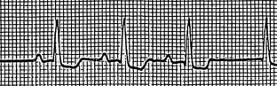

Here’s the opposite of premature nodal activity. Here’s a nodal beat – no p-wave, and normal QRS conduction, just like in a sinus beat. But is it early? No – actually it’s a little late. This is a rescue situation, not unlike demand pacing. The SA node, for some reason, probably ischemia, is slowing – and the AV node, like a demand pacemaker, senses the time difference, and jumps in with a beat to replace the one from the SA that never came. They call this an “escape beat” – I think of it more as a “rescue beat”. The AV node loyally sits there passing along beats from above, all it’s life, and then one day, the SA node gets hit by some bad cheeseburger byproduct, and the AV node wakes up and starts delivering a rhythm on it’s own. If you’re lucky. If not – you know how to work the external pacemaker, right?

As you work your way through all these rhythms, try to get a sense of which beats are coming early, which are coming late, and why. The early, or premature beats are the ectopic ones, coming from someplace that they’re not supposed to. The late beats, at least these nodal ones, aren’t ectopic really, because they do come from an “intrinsic pacemaker”, right? – the AV node. I think of the premature beats as “abnormal” more than I do the nodal ones, except that the nodal beats wouldn’t be appearing if the SA node weren’t in trouble…

6-12: Escape capture bigeminy

This is a complicated name for the rhythm in which sinus beats alternate with nodal escape beats. This is probably happening for an unhappy reason, like MI or ischemia affecting the SA node – the AV node is having to rescue the rhythm with every other beat – I’d worry if I saw this one, because heart block might be coming. Any disease process that affects the rhythm that much has probably done some real damage to the SA node. There’s lots more (why do I keep hearing this phrase?) about heart blocks and pacemakers in the FAQ files with those titles.

6-13: Junctional rhythms

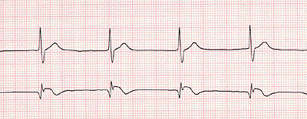

medlib.med.utah.edu/kw/ecg/mml/ecg_junctional.html

Everybody see what’s different about this one – what’s going on here? Let’s be systematic about it: are there p-waves? I don’t see any. But do the QRS’s look normal? Yup, normal. So what have we got - let’s visualize this please – you in the back, you all visualizing this? Are the atria doing anything? Not that I can tell, they aren’t. Ventricles? Yes they are. And since the QRS’s appear normal, this means that the rhythm has to be coming from the junction, and going southwards. Everybody see that? What about the rate? About 40. Perfect! Junctional! Dude!

6-14: Accelerated junctional rhythms

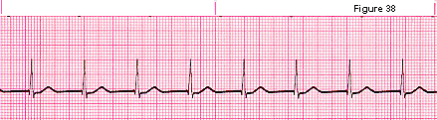

This ought to be pretty much the last of the supraventricular rhythms that we’re going to look at. I’m sure there are more, but these cover pretty much the ones you run into in the MICU setting. As usual, please let me know what I’ve left out!

This is a junctional rhythm too, but obviously it’s faster - 80’s - than the normal 40-60 rate that you’d expect. Anybody know why this happens? – I have no idea. It’s generally considered benign – one thing that does matter however is that the patient loses whatever atrial kick they had – this can be as much as 25% of the total cardiac output. Like afib…

6-15: What if the atria and the ventricles aren’t talking to each other? How can I tell?

6-15-1: What is AV dissociation?

I’ll explain this as I understand it (which is what everybody does, right?) – this can happen in a couple of different ways, for a couple of different reasons. Here’s the first one:
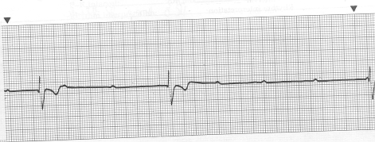

You all know complete heart block when you see it? Look at all those p-waves floating around, lonely, on an empty isoelectric sea with no QRS’s to talk to. Here’s how to tell if your patient’s atria and ventricles aren’t communicating: it has to do with the relative rates. What’s the atrial rate here? Let’s count boxes going to the right from the p-wave just above the “?” in the first line of this paragraph: 300-150-100-70 – somewhere in the sixties. How about the ventricular rate? Yow! – wicked slow, as we say up here in Mass. – somewhere around 20. And irregular, at that. The SA and AV nodes aren’t communicating very often, if at all, and the AV node isn’t doing much, although it seems to be trying.
Is there:

- “a”: any kind of visible relationship between the p’s and the qrs’s that you can see?

- Or “b”: are the p’s just sort of appearing in amongst the QRS’s at random? I’d say “b”. And is there any kind of predictable ratio between the p’s and the qrs’s? Such as 2:1, or even 8:1, or some varying number? Not really. Take a look at the “Heart Block” FAQ for more on this subject.

Oh, yeah – just by the way – why is this happening? What would you do in this situation?

Here’s the second scenario:

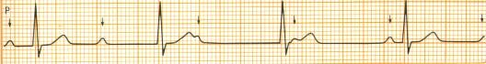

The folks who recorded this strip have helpfully put little arrows showing that the p-waves are actually popping up all over the place. Even though the last complex looks normal, that’s actually just a lucky hit – the atria are doing their thing, and the ventricles are doing theirs, but they’re not on speaking terms. Ready for another question? Where are the QRS’s originating?

This is almost the same thing as complete heart block – actually, it probably is complete heart block, but difference is in the ventricular rate. Complete heart block usually describes the first situation, in which the junction isn’t generating much of a rate at all.

This second strip describes the situation that people call “A-V dissociation” – it involves the same kind of non-communication, and probably for the same reasons: ischemia or MI, but produces a different effect. This person is a bit luckier than the one above. Clearly! This time the AV node is still able to work in “escape”, or “rescue” mode. But the signal isn’t going across the little bridge there, from the a’s to the v’s.

Now – just because this one looks a bit better doesn’t mean that things are ok! Something has hit the signal transmission system, hard!, (what kind of MI would it probably be?), and you’d better know who’s on in the cath lab… remember, the AV node is not a reliable pacemaker – it can poop out at unpredictable times, and there you are, up the cardiac creek without an escape rhythm to paddle with.

But do you see how the clue to dissociation is that the rates are different? – that’s the clue that the nodes aren’t communicating. Usually the atria are inhibited in a junctional tachycardia – sometimes a signal coming from the AV node will actually depolarize the atria backwards – upwards! This can show up in a couple of ways: the p-wave may be abnormally short, maybe upside down, maybe on top of the QRS. All in all – something isn’t right, because the signal transmission isn’t happening the right way. Watch these folks carefully.

6-15-2: What does “marching out” mean?

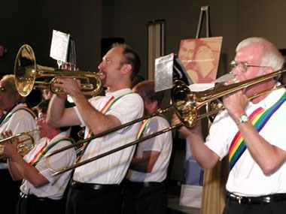

http://aen.org/photos/0205/atlanta.freedom.marching.band.jpg

This is actually simple – it means that impulses, or signals, no matter where they’re coming from, are coming regularly: either p-waves, or QRS’s. This is where calipers come in handy. Take another look at the strip of complete heart block above. Now take your calipers, and point one end at one of those sad little p-waves floating around all alone, and put the other end on the p-wave nearest to it. Now, holding the calipers with the points in that position, see if the p-waves coming before and then after those two are coming in regular rhythm, which on EKG paper means: “the same distance apart”. They do on this strip, right? They march out. The caliper points always touch two p-waves, no matter which one you use to start with. So now you know that at least one pacemaker is trying to work properly. Which one is it? How about the AV node? Do the QRS’s march out? Can you even tell? How about in the second strip?

Even Further On South…

Everybody’s starting to realize how this file is organized, right? The first part is about arrhythmias coming from the upper part of the heart, and we’re moving downwards in sequence. Just making sure everyone was awake…

- What ventricular arrhythmias am I likely to see in the MICU, when should I worry about them, and how are they treated?

7-1: PVCs - Premature Ventricular Contractions

These are pretty easy to recognize. A couple of points to make:

Premature ventricular contractions – they’re early, as in the strip above- which is to say they come sooner, or faster, than the sinus beat would. Since they’re faster, they capture.

Ventricular: They’re ectopic, coming from a focus somewhere in, uh… the ventricles!

Why do they look so strange? Let’s put this one to the audience. Why do PVCs look the way they do? The clue is: which way is the signal travelling?

Why are they happening? Context is everything. If your patient has been in perfect sinus rhythm, and suddenly develops PVCs, your task is to figure out if something has changed. Or the other way – have the PVCs suddenly gone away? Then again, some people have chronic ventricular ectopy – they may even have short bursts of VT – these will usually be patients with stretched, boggy hearts: people who have had a couple of MIs, people with cardiomyopathy, CHF patients – you get the idea. We say: “Oh, he’s allowed to have short runs, he has lots of ectopy all the time. What’s his last Mag?”

Things that cause PVCs: by now this should be clear enough – anything that interferes with the delivery of blood; things that make the heart unhappy: ischemia, MI, hypoxia, electrolyte problems.

PVCs may or may not make a blood pressure. You can observe this really well if your patient has an a-line – just look at the arterial waveform following the PVC – is the wave lower than one following a sinus beat? Probably. If your patient has a run of PVCs – are they all lower than the sinus pressure? Did your patient lose pressure completely with the run? You’ll see nurses respond to a VT alarm by going over to the central monitor, looking at the printer strip, and saying “Wow, he doesn’t perfuse those beats very well! Sure looks like VT to me - the team has been having a hard time figuring out exactly what the rhythm is. Whatever it is, he doesn’t like it very much.”

This is an essential point of “surviving” the arrythmias that you will run into in the MICU. Your patient may make a fast rhythm of one kind or another, the cardiologists may have a great time debating whether it’s “type-2-accelerated-idioventricular-rhythm”, or “rapid-a-fib-with re-entrant-something”, or “nonsustained-supraventricular-tachycardia with pre-excitation syndrome of the Lown-Ganong something else…” – your immediate problem is what? All together now: Is the patient making a blood pressure? If she is, this does not mean (obviously) that you can now go downstairs for lunch! Get the patient seen by the team, don’t leave the room - the rhythm may deteriorate into something you will recognize – as bad!

7-1-1: What are couplets? Triplets?

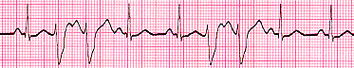

Couplets are easy – two PVCs in a row. Again, context is everything. Has your patient had couplets before? Or never before? Is she doing something clinically – having chest pain, getting hypoxic, sweating, getting restless? Is her K+ low, or magnesium? Is she acidotic?

Or is this an improvement? Has she been having long runs of VT, which are now going away because you started lidocaine?

Are you sure that’s actually your patient? (Not a stupid question when you’re using remote central monitoring.)

So, couplets: easy to recognize, but don’t forget to try to figure out what they’re telling you.

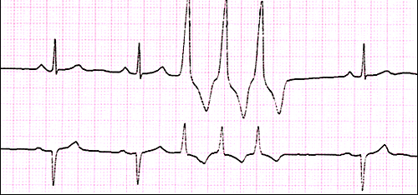

Triplets: same as couplets, except three PVCs in a row.

7-2: What is bigeminy, trigeminy, quadrigeminy?

Bigeminy means that every other beat is ectopic. Trigeminy means the same, for every third beat. Quadrigeminy for every fourth. This strip goes from bi- to tri-. Once again – put this into context: is this acute or chronic? Does his ectopy go away if his K, or his Mag is low? How would you treat the low K? Would you take KCl on an empty stomach? What do BUN and creatinine have to do with giving K replacement?

7-3: What is a “run”? What is a “salvo”? (Ahoy!) What is “non-sustained VT?”

These are all pretty much interchangeable terms for a series of PVCs that’s “longer than a triplet”. Some runs are short – maybe 6 beats long, some are lots longer, but the main idea is that the run stops by itself, and the rhythm goes back to whatever (hopefully stable) it was before. You’ll hear the alarm go off, and the board will say “VT alarm” – your job is to check things out: go to the patient’s room, then go over to the printer and look at the strip printout.

Round up the usual suspects: are the runs coming when the patient is doing something else that might indicate trouble? Angina, diaphoresis, changes in electrolytes, hypoxia, fluid overload, evolving an MI? What is this run of VT trying to tell you? Or is the patient “allowed to have runs of VT”? Maybe he shouldn’t!

A lot of the VT alarms are artifact caused by people moving, or scratching. Water in corrugated O2 tubing can collect in the bend where the tube hangs down, and vibrate as the air is pushed through – I’ve seen this produce artifact that looks just like VT. Chest PT will do it.

What you have to do though, is to darn well go down to that printer and check the alarm printout every single time. No exceptions. You might think: “Well, Mr. Gerbilowitz has had artifact 32 times already this shift”, but you’d hate to be wrong… Often artifact problems can be fixed by changing chest electrodes – I usually take them all off, and replace the whole set. Another useful trick is to move the electrodes inwards on the chest towards the borders of the heart – people who have lost cardiac muscle mass often have very small ekg complexes, and you can see them much better this way.

7-4: VT

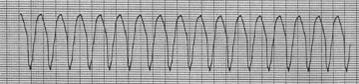

www.mediscan.co.uk

Now things are starting to get a little scary. Now is when you need to remember your ACLS class, and/or your defib class. Take a look at the faq on “Defibrillation”.

Same phenomenon as a triplet, except “sustained”. VT is really one of the scariest things that comes up in the MICU, along with it’s nasty cousin VF. This might be a good place to talk about lethal emergencies.

- Rule one: do your best to keep from getting panicky. Always remember that the MICU is a group process. You are never, ever alone. Senior staff nurses are always around.

- Subrule to rule number one: the only way to get over being afraid of these situations is to spend a lot of time in the unit doing them. Everyone has trouble with this at first.

- Rule two: remember the basics, and keep it simple.

Let’s take a minute at this point, and walk through a scenario briefly. The VT alarm goes off – you turn your head to look at the central monitor, and there it is – the real thing. You immediately go into VT yourself, but because you are probably about a third of your patient’s age, you still make a blood pressure, so you can still stay upright. You bolt for the patient’s room.

First move is? Call for help as you run.

Second move? Always the same – let us stress this: look at the patient. Is she smiling at you? Comatose? Seizing? This is what the CPR course means by “establishing unresponsiveness”. You need to know that some patients can make an adequate blood pressure with VT, maybe for a short time, maybe for quite a while. They may be awake, may be having chest pain, may not be feeling anything at all. You do not want to start running a code on a patient who is awake! This is what ACLS is all about – learning what to do in different situations.

Let’s take the unresponsive scenario. Very important, you must say the following words very loudly: “Annie, Annie, are you all right?”. This usually works in class, anyhow. She never says much though – unresponsive. You’ve run down the hall, called for help, you arrive in the room, you determine that the patient is not responsive. Is the rhythm still VT? Old guy that I am, I would thump this patient – I’ve done it enough through the years to know that it works sometimes. This has become a debatable move nowadays, and it’s been a while since I took ACLS – can anybody clear this up from the group?

I remember one episode: I was standing by the bed in the patient’s room, and the crisis alarm went off – I heard it coming from her bedside monitor, about a foot above my head as well as from the hallway. I looked up – VT! Low, or no blood pressure on her A-line trace. I looked down – her eyes had closed, she was shivering – maybe seizing? I thumped her – this all happened in about the space of seven seconds. She broke immediately into sinus rhythm. The team came bolting into the room at the call of the nurses at the station, who’d seen the rhythm on the central monitor – and came to a screeching halt, burning rubber. They looked at the monitor, looked at the patient, looked at me, standing there with my fist in the air. I looked at the monitor, looked at the patient, looked at them. Yikes!

Where were we? – oh yes. Keep it simple. Remember that stuff in Basic Life Support CPR about A, B and C – Airway, Breathing, and Circulation? Same deal applies. Lethal arrhythmia?- sure, you want to shock them, but remember to get the backboard under them, start compressions, establish an airway – here, let’s scenario-ize this one too.

Alarm goes off. Mr. Hamsterowitz is in VT – not artifact this time. You run down the hall from the central monitor, you’re calling for help, you try not to plow into the other nurse coming from the opposite direction. There’s Mr. Hamsterowitz – not looking too good. Bedside monitor clearly shows VT. No BP – well, maybe a little BP on the A-line trace. Not enough to perfuse his head, clearly, since he is really not responsive. First move? I’d thump him. I understand that this has to do nowadays with “witnessed” vs. “unwitnessed” events – as far as I’m concerned, in the MICU they’re all witnessed, so I’d thump him. Do not let thumping or anything else get in the way of defib maneuvers, however.

Second move – did he break from VT with the thump? No? Get him lying down, get the board under him – one poor nurse I know, in her first code, swung the backboard over the bed and clocked the nurse on the other side, right upside the head. Start compressions. Is the airway open? No? Is he in VT because he aspirated a piece of steak? Did you have to push his dinner tray out of the way when you got into the room? How are you going to clear his airway in this position?

Or: airway’s open? Got an oral airway in place? Good motion of the chest with the ambu-bag? Holding his chin the right way? Remember how to hold his chin?

Here’s an important point that I try to emphasize: take your time. Doesn’t sound right, does it? But look, you’re in a very controlled environment. You have all the personnel and equipment around you that you need. You have what – 3 to 6 minutes before the patient sustains anoxic brain damage, and that’s if you’re not doing anything! So you really do have all the time you need. Take a deep breath, and take a few seconds, and just think of the ABCs – then get on with the fancy stuff.

Okay, here comes the defibrillator. What’s the rule nowadays? – it’s been a while since I did ACLS. For VT, I learned that the maneuver to make was to do a synchonized cardioversion. Let me lean over and ask my wife, who is an ACLS instructor. Okay – here’s the word. For pulseless VT – shock the patient as if they were in ventricular fibrillation; that’s to say, unsynchronized DC countershock, starting with 200 joules. Didn’t work? 300 joules. Still didn’t work? 360 joules. For VT with a pulse, if they’re unresponsive but very hypotensive, she says you can try doing a synchonized cardioversion at 200 joules, but it may not be worth it. Make sure they’re not awake! Don’t forget the paddle gel! (Update comment – recently we changed to the new biphasic defibrillators, and the joule numbers are different. Assignment to the class – somebody look these up and send them in.There’s more on defibrillators, how they work, and what joules and things are in the Defibrillation FAQ. We’ll have to update that one too.

One more point. There really is no reason to yell and scream and shout in a code. A well-run code is quiet. There may indeed be lots of activity, but the basics, the basics, the basics are being done – A, B, and C are established, IV access is established, drugs are coming in, equipment is being used – you have a great deal to contribute by staying calm, and communicating your sense of calm to the others. You’d be amazed how much this can help. Don’t yell. Speak clearly. Make sure someone is in command – it may have to be you at first! Give the process time – I always say that the first, oh, 125 codes are the toughest…(grin!)

7-5: VF – Ventricular Fibrillation
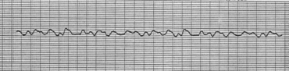

Here’s another big scary one. For this one you want to shock them as soon as possible, no cardioversion, no synchronization, no nothing but electricity, 200 joules, as quickly as possible, followed if necessary by 300, then 360 joules. Keep the paddles on the patient’s chest between shocks. Establish ABC, get ACLS going.

7-6: What is the difference between “narrow complex” and “wide complex” tachycardia?
We’re speaking honestly here? Well honestly, I think there’s a reason why the Great Nursing Supervisor invented cardiologists. Narrow or wide complex, my concern is: are they making a blood pressure? If they are – call for help and monitor closely. If they’re not, call for help and start a code. This is not to say that narrow versus wide doesn’t exist, or matter – they do, and it does, and you will see this kind of thing. But the practical principle for you as the person at the bedside is always the same – is the patient perfusing with this rhythm? Get all the help you need. I guess I should say that my own interpretation is that wider complexes tend to be coming from lower down, and therefore are probably VTs – and that narrower complexes are probably coming from higher up, and may be things like SVTs – supraventricular tachycardias. Compare the VF strip to the PAT strip, and you’ll clearly see the difference.

7-7: What do I do if I see VT on the monitor?

Pretty much as described above. Try to remember which patients are DNR… make sure you get the strip from the printer. If the run breaks on it’s own, count the beats in the run, and document it that way: “Patient had two episodes of wide-complex tachycardia (ha!), one 22 beats, the other 30 beats. Potassium and magnesium repleted, am levels pending., O2 sat > 95%, strips taped to flow sheet.”

7-8: What if the patient is still awake?

Don’t shock her! Don’t thump her either. Call for help, get the team to the bedside, monitor her closely because she may lose her pressure at any time – at which point you can thump, or shock her. Patients in this situation are very tenuous - watch them very carefully. Usually the goal here is “chemical cardioversion” – up until very recently all these maneuvers were made with lidocaine boluses and drips, followed sometimes by procainamide, but just recently I understand that amiodarone has come into the situation. Here’s my wife, also a MICU old-timer, speaking from the couch on this subject: “People still use lidocaine in this situation because that’s what they always did, so they just keep doing it, but it’s of indeterminate value.” (Can you tell that she’s in grad school?) “There have been no studies that show that lidocaine is really effective – it’s all anecdotal. There’s been one really good study out of Seattle called the ARREST study, that showed significant improvement in this kind of situation when people were treated with amiodarone.” Whoa! You go, my girl!

Update: yup – amiodarone. Either 150 or 300mg IV followed by an appropriate drip…

7-9: What if the patient rolls up her eyes and becomes unresponsive?
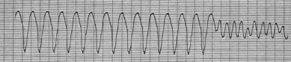
This is why you were watching them…

7-10: What is a precordial thump? Does it work?


Jayne says that they don’t teach this maneuver any more in ACLS, but that most experienced folks use it. The thump is a carefully delivered punch in the chest – (my parents always taught me not to hit people, so this is hard for me). The idea is to strike downwards with your fist onto the middle of the sternum, right around where you’d do compressions, from a height of about 18 inches, full force, hitting with the fleshy part of your fist instead of the knuckles. I’ve seen this work myself, as I’ve mentioned above, and I’d always want people to know how useful it can be. You’ll hear the old nurses stand up when they see VT, and yell down the hall: “Hit him!”

Well, you could do it this way…

http://www.ingber.com/karate00_keri_no_kata/keri_27.jpg

7-11: What if I see VF on the monitor?

Make sure you look at the patient before you code him! Here’s a relevant story from awhile ago – during the last Ice Age, seems to me. I was working with a new nurse on one of the floors. She had a patient on a monitor, portable job outside in the corridor, and the nurse’s task was to read the monitor every hour, and document the rhythm. A really frightened shout from the nurse down the hall – I bolt down there – the patient’s wires had come loose, she’d seen something scary on the monitor… next night, same nurse, same patient, another shout from down the hall – the patient was in unresponsive VF. Full code. No go. Holy cow – that was literally twenty years ago, the last time I did mouth-to-mouth…something you don’t forget.

7-12 What is Torsades des Pointes?

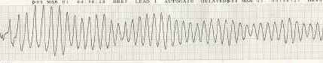

http://www.ekgreading.com/AVB_torsades.jpg

This is a weird one, and a bit rare, but you should know about it. Torsades is an unusual kind of VT. In “normal” VT (ha!), you could think of the electrical signal going through the heart, back and forth, through the tissue, zipping along, but always along one axis, one direction of travel. In Torsades (they also call it “polymorphic VT” – actually, whichever one you call it, they’ll call it the other one…), the axis actually rotates as the arrhythmia goes along – it swings, rotating around the heart, as though around a pin stuck in the middle of the heart. There’s a lot of scholarly debate about what to do for this arrhythmia – my experience is by the time we’ve done shocking them in the regular ACLS way, there’s not much point in arguing. The question then becomes: why did they get it? My understanding is that certain meds are usually the problem – they cause the QT interval to get longer and longer, which in turn tends to set off this unpleasant problem. I’ve seen Haldol do this, and I’ve seen patients sedated with Haldol get taken off it, as their QT interval has been seen to get longer. Does this happen in quinidine loading? Procainamide loading? I forget – anybody know? I need to look this one up again…

Update – magnesium turns out to be just the thing for Torsades.

7-13: What is AIVR?

Here’s how I understand it: the ventricles can generate their own escape rate, just as the AV node can, called the “idioventricular rhythm” – it’s very slow, around 20-40bpm, and it looks like this:
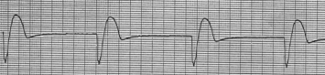
See any p-waves? No p-waves. Wide and bizarre? (What do you mean, “Your mom was wide and bizarre!”?) Pretty bizarre, anyhow – this and the rate tells you where the rhythm is coming from – low down in the ventricles. Very slow – not really fast enough to do what, group?: (all together now) “Generate a blood pressure!!” Right. Thank you.

The “A” in AIVR stands for “Accelerated”. Meaning exactly that – the strip shows an idioventricular rhythm: no p’s, coming from the ventricles (remember how to tell if it’s coming from the ventricles in lead II?) – but an AIVR will be faster than the “normal” idioventricular rate of 20-40 bpm. Maybe 60, or faster even. Will this rhythm perfuse? Maybe... hhe ventricles will pump, if sort of slowly. Will this patient have, or not have, the benefit of atrial kick?

The mechanism here is like the escape, or “rescue” mechanism in the accelerated junctional rhythm. The AV node speeds up, for reasons of it’s own which I certainly don’t know about, (but which the cardiologists don’t seem worried about), and so can the ventricular pacemakers speed up – and, they capture – assuming they’re running faster than whatever the underlying rhythm is. Let’s say you’ve aggressively beta-blocked your patient down to, say, a sinus rate of 50. That’s somewhere around the intrinsic junctional rate, correct? A frisky nodal, or even ventricular pacemaker might wake up and capture at a similar rate… “A” - IVR. As long as it’s fast enough, it will provide a cardiac output the same way that (slow) ventricular pacing would.

People don’t get upset much about regular AIVR - the feeling seems to be: so the ventricle woke up and captured, so the patient is a little too beta-blocked, big deal – hold the next lopressor dose, I’m going to bed. There’s a rare second kind of AIVR, just in case you really wanted to know – irregular AIVR. This one is dangerous – I seem to recall being told that it’s functionally the same as complete heart block. I don’t think I’ve ever seen it, unless while watching that sad “rhythm of death” you see on the monitor just before your patient passes away…

7-14: Asystole
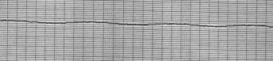
Oh dear…

8: Things we left out the first time:

8-1: SVT: Supraventricular Tachycardia

SVT is nasty, it’s fast, it’s kind of the same as VT except different… let’s think about this one for a second. If ventricular tachycardia comes from the ventricles, and is therefore wide and bizarre (Hey! Don’t talk about my aunt like that!)… and SVT is supra-ventricular, coming from someplace above the AV junction…then what’s it going to look like?

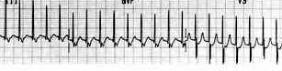
Is it going to be wide? Nope, probably not, because it isn’t coming the place where the wide beats come from…

This is where the whole discussion about narrow-versus-wide complex tachycardias raises its head. Which is this one?

What to do? SVT is not the most common arrhythmia, but you need to be ready – as with all of them, your worry is: is my patient making a pressure with this rhythm? And will it get worse?

Well – of course it’s never really that simple…it turns out that there’s about twelve kinds of SVTs…if you really want the workup, you’ll have to call Jayne and make an appointment in her EP lab!

As a practical matter, I’ve seen regular SVTs-with-a-pressure treated with adenosine: 6mg IV, then 12mg; and SVTs-with-a-horrible-BP treated with synchronized cardioversion.

8-2: WPW – Wolff-Parkinson-White Syndrome

(Do they call it “Dubya P. Dubya” in Texas?)
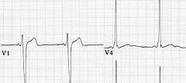
Nothing very new about this one, and it’s kind of rare, but it’s cool, and pretty interesting to an old CCU geek like me.
WPW stands for “Wolff-Parkinson-White” syndrome. See what the arrow is pointing at? At the beginning of the R-wave, after that really short PR interval, there’s a short diagonal segment – called the “delta wave” - leading up into the normal part of the R-wave at an angle. Hard to see. “Subtle” is the word they use. Not to worry! – after about a decade of reading EKGs you’ll have no problem at all. Maybe two. Yeesh!
http://www.medlib.med.utah.edu/kw/ecg/mml/ecg_12lead018z.html
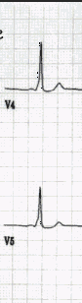
Here’s some more – see the delta waves?
The significance is actually serious: people with WPW have an extra conduction tract built into their hearts by accident, called the “accessory pathway”, which goes around the AV node, connecting the atria and ventricles directly. The accessory tract lets conduction signals go back around and around into the normal pathway instead of having them sent along towards the ventricles, producing a very rapid paroxysmal SVT. Treating the SVT: valsava maneuvers, putting the face in ice water (hmm – not sure how I feel about that one…), or verapamil, or adenosine. (Giving adenosine always makes me feel like I’ve gone into an SVT… and no matter how much of a valsava I do, it doesn’t seem to fix the patient. Maybe I should start putting my face in ice water…)
Here’s a quote from the “Virtual Naval Hospital”: “Patients with WPW should not be treated with maintenance dose verapamil or digoxin, regardless of the response of their PSVT to acute administration. Symptomatic patients with WPW should be treated with cardioversion or IV procainamide, and referred to a cardiologist for electrophysiologic evaluation.”

http://medlib.med.utah.edu/kw/ecg/mml/ecg_12lead018z.html .

- Quiz Questions

As usual, our sense of humor invades everything here at ICU faqs central… these quiz questions are not designed to be comprehensive, complete, or authoritative. They are meant to help you think a little, maybe smile a little… let us know if you have questions to add…

- An arrhythmia is defined as:

  - an alteration in the normal rhythm of the lungs
  - any rhythm that comes from someplace that it shouldn’t, like Queens instead of Brooklyn
  - any rhythm that begins with the letter “a”
  - any cardiac rhythm apart from normal sinus rhythm

- People develop arrhythmias because:

  - their electrolytes are out of whack
  - they’re having myocardial ischemia
  - they’re confused
  - one or another of their cardiac chambers has become stretched
  - all except c, except maybe sometimes

- The bedside difference between a bad arrhythmia and a not-so-bad arrhythmia is:

  - a bad arrhythmia will kill a person, and the other kind won’t
  - bad rhythms don’t make a viable blood pressure, and the other kinds do
  - bad rhythms usually come from lower down in the heart, rather than higher up (although not always)
  - there are no “bad arrhythmias”, and we shouldn’t be so judgmental!

- Ectopy is:

  - spelled “ectopy”
  - spelled “ectopi”
  - something that shows up where it shouldn’t be, like Dad at a rave club: “Mom! It’s me! Dad’s being ectopic again!”
  - animals that live in the ocean, with tentacles, that squirt ink
  - a and c

- Supraventricular means:

  - much better than ventricular
  - coming from anywhere except the ventricles
  - coming from anywhere above the AV node
  - that my ventricles are better than somebody else’s

- Sinus arrhythmia is:

  - the one that shows up when you get a head cold
  - a really dangerous arrhythmia
  - the one that young people often get, in which the heart rate varies a bit with their breathing, and which is considered benign
  - there’s no such thing as sinus arrhythmia

- Sinus bradycardia:

  - should always be treated with atropine
  - should never be treated with atropine
  - should be observed, and considered in the context of what’s going on with the patient
  - might be treated with atropine if it causes dangerously low perfusion pressure
  - might be the result of a pressor bolus
  - c, d and e

- Sinus tachycardia:

  - should always be treated with atropine
  - should never be treated with atropine
  - should be observed, and considered in the context of what’s going on with the patient
  - might be treated with atropine if it causes dangerously low blood pressure

- PACs:

  - are also known as APCs
  - are also known as PVCs
  - are also known as FLBs
  - were what they called girls in the British army during World War II
  - a and c

True or False:

- Atrial bigeminy is a horrible, terrible, terrifying, lethal arrhythmia that needs immediate cardioversion, defibrillation, and external pacing.

- Atrial flutter is a horrible, terrible, terrifying, lethal arrhythmia that needs immediate cardioversion, defibrillation, and external pacing.

- Atrial fibrillation is a horrible, terrible, terrifying, lethal arrhythmia that needs immediate cardioversion, defibrillation, and external pacing.

- Nodal beats:

  - come from the SA node, which is also known as “the junction”, or “the node”
  - come from the AV node, which is also known as “the junction”, or “the node”
  - are like sick sinus beats, coming when the patient has a cold in the node
  - may represent ischemia of the AV nodal territory
  - b and d

- “Escape” beats are:

  - ectopic beats that come from the brain
  - ectopic beats that come from anywhere besides the heart
  - ectopic beats from anywhere in the conduction system, but usually the AV node, which take over the job of generating a rhythm, and therefore chamber contraction, if the normal SA – node beats don’t show up on time
  - dramatic drumming soundtracks used in adventure movies

- AV dissociation is:

  - the club that the nerds belonged to in high school, who ran the film projectors at assembly
  - what’s happening when the atria don’t talk to the ventricles, and each set of chambers beats independently, probably as the result of ischemia or infarct
  - when they remove the letters between A and V in the alphabet
  - an alteration in cardiac output, potential
  - an alteration in cardiac output, actual
  - b, probably d, and usually e

- Marching out means:

  - being a band geek on St. Patrick’s day
  - being a band geek on Stonewall day
  - the interval between p’s remains the same, the interval between QRS’s remains the same, even if the p’s and QRS’s aren’t connecting to each other
  - the intervals between the p’s and the QRS’s remains the same

- PVC’s are:

  - large off-road vehicles used by the National Cardiac Forest Service
  - early beats coming from the ventricles
  - a sign of ischemia, sometimes
  - a sign of electrolyte disturbances, sometimes
  - b,c and d

- Couplets are:

  - lethal, and need to be treated immediately with lidocaine, amiodarone, potassium, and kayexelate
  - twin babies with cardiac problems
  - a form of poetry, usually romantic
  - two PVCs in a row, something to be monitored in the patient’s clinical context
- Triplets are:

  - even more lethal than couplets, and need to be treated immediately with potassium, magnesium, lidocaine, amiodarone, atovaquone, and ECMO
  - three babies, but with no cardiac problems
  - not usually poetic
  - three PVCs in a row, a little more worrisome – this could signal a long run of VT coming

True or False:

- Patients in VT should be immediately defibrillated.

- Patients in VF should be immediately defibrillated.

- Patients in Torsades des Pointes should be immediately defibrillated.

- Patients in asystole should be immediately defibrillated.

- There is no such thing as Wolff-Parkinson-White syndrome, and if there is, all patients with it should be immediately defibrillated.

Strips: no answers are given (grin!) – got to figure these out on your own!

- This is:
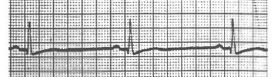

http://tooldoc.wncc.edu/mi/mi8.JPG

  - supraventricular tachycardia, with aberrancy, Type 1
  - supraventricular bradycardia, Lown-Ganong variant Type 3a
  - an irritable focus flipping the bird
  - sinus bradycardia

- This is:
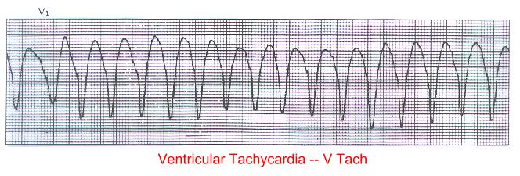

http://tooldoc.wncc.edu/mi/mi18.JPG

  - sinus bradycardia
  - ventricular bradycardia
  - ventricular brady-bunchia
  - wide-complex tachycardia, probably VT
  - I don’t know what this is
  - all of the above
  - none of the above

- This is:
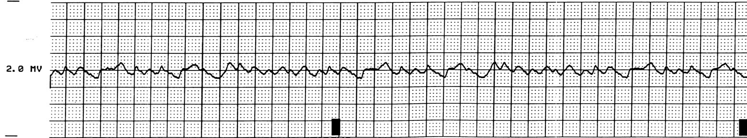

http://www.mf.uni-lj.si/mmd/cardio-a/eng/sz-50/sldr00014.html

- sinus something
- ventricular something
- the wires are off…
- call a code!

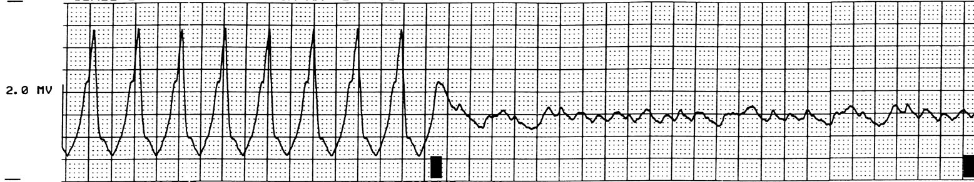
- This is:

http://www.mf.uni-lj.si/mmd/cardio-a/eng/sz-50/sldr00015.html

  - one real ugly thing turning into another real ugly thing…
  - VT turning into VF
  - who forgot to hit the bleedin’ sync button on the cardioverter!
  - probably the result of the R – on – T thingy
  - all of the above

- This is:

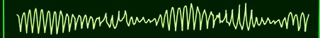

http://www.realcor.com.br/arquivo_digital/img/Torsades.jpg
- a totally fake arrhythmia
- torsades de pointes
- the march of the toreadors
- what happened to my rhythm when I ran with the bulls in Pamplona

- This is:

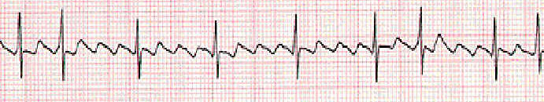

http://medicine.gotohamed.com/EKGs_files/Lectur14.jpg

- atrial trigeminy
- trigeminal neuralgia
- bigeminal atrialism
- atrial flutter with variable conduction

- This is:
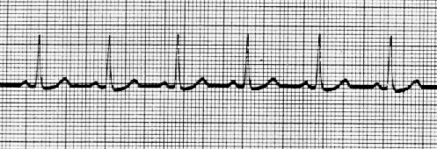

http://www.ce5.com/wpeD.gif

- normal sinus rhythm

